

Facilities Management Services
- Cleaning
- Hygiene
- Pest control
- Waste Management
- Gardening Services
- General Supplies

COMPANY
PROFILE

M A K I N G A D I F F E R E N C E

Nozinga Group Pty Ltd is a multi-disciplinary hygiene services provider aimed at providing innovative, environmentally sustainable hygiene and facilities management solutions.
Nozinga Group Pty Ltd was established in 2012, heeding the call to provision of green Facilities Management offerings in all sectors of the economy. To date, the group has managed to establish a footprint in the power generation, food and beverage and public sectors in the country.

We are passionate

about the work we do and the people we employ thus, we are registered with the Compensation for
Injuries and Diseases.
We also subscribe to strict Occupational Health and Safety practices.
Nozinga Group Pty Ltd specialises in Facilities Management Services,Cleaning, Hygiene, Pest control, Waste Management, Gardening Servicescand General Supplies solutions aimed at the industrial markets, bringing a unique flair of ingenuity and novelty to our clients.
We pride ourselves with commitment to excellence, quality and our constant endeavor to reduce the carbon footprint in all our offerings. Our SABS approved suppliers have developed products
around the scope of current regulations and requirements as set out by International Environmental certification bodies.

The group has national footprint in the following provinces:
- North West
- Eastern Cape
- Western Cape
- Limpopo
- Kwa-Zulu Natal
- With its head office in Johannesburg, (Gauteng)


ABOUT
Mr Unathi Thonga is the Group Executive Director and is responsible for strategic business direction including sales and marketing. Unathi has extensive experience in Sales and Marketing, Total Facilities Management derived from a 12 year career in various spheres and sectors of the economy.

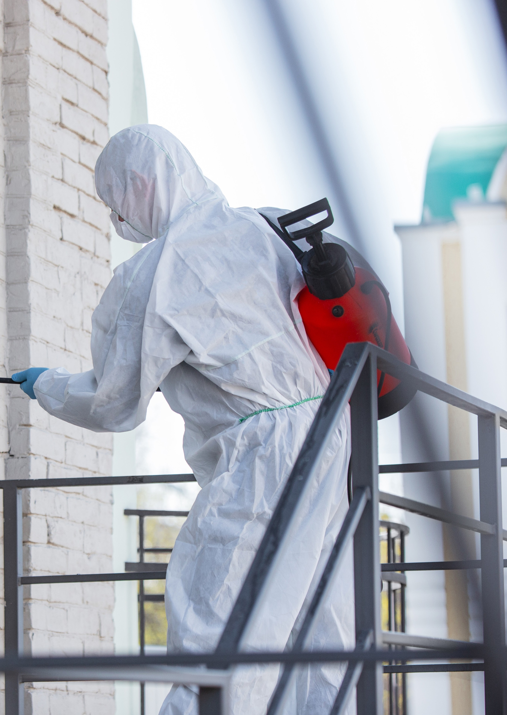
NOZINGA GROUP - COMPANY PROFILE

M A K I N G A D I F F E R E N C E


 Mission

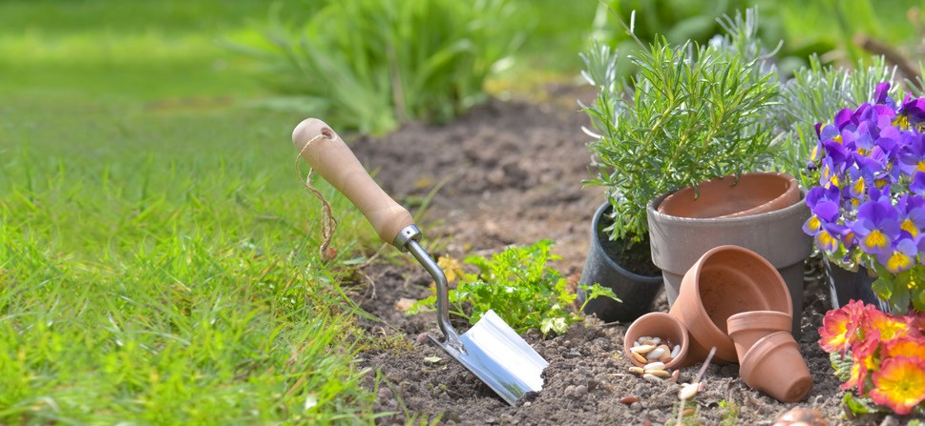
Our mission is to utilise environmentally sustainable, innovative total facilities management solutions to provide excellent cost effective services to our clients. Whilst we seek to generate profits, it is within our mission to ensure that real benefits accrue to our clients.

Vision


We strive towards embodying leadership in provision of customised turnkey hygiene and total facilities management services that exceed our client’s expectations.

Values

Our values include:
- Striving towards service excellence
- Provision of exceptional quality services
- Loyalty and integrity to the clients that we serve
- Professionalism and ethical conduct in all our interactions
- Continuous improvement and innovation in all its forms

 Philosophy

Our goal is to provide pragmatic and market relevant services that aim to grow our business and expand our areas of operation, making a significant contribution to our client’s environmental goals. At the core of the company lies the belief that innovation and service excellence are key success factors in achieving this. Thus, the ethos of our brand is entrenched in continuous improvement.

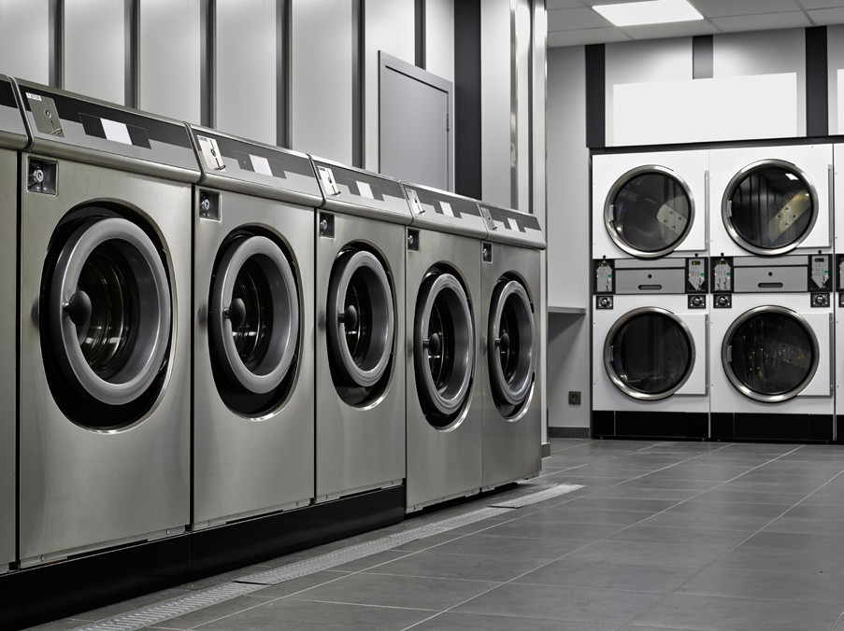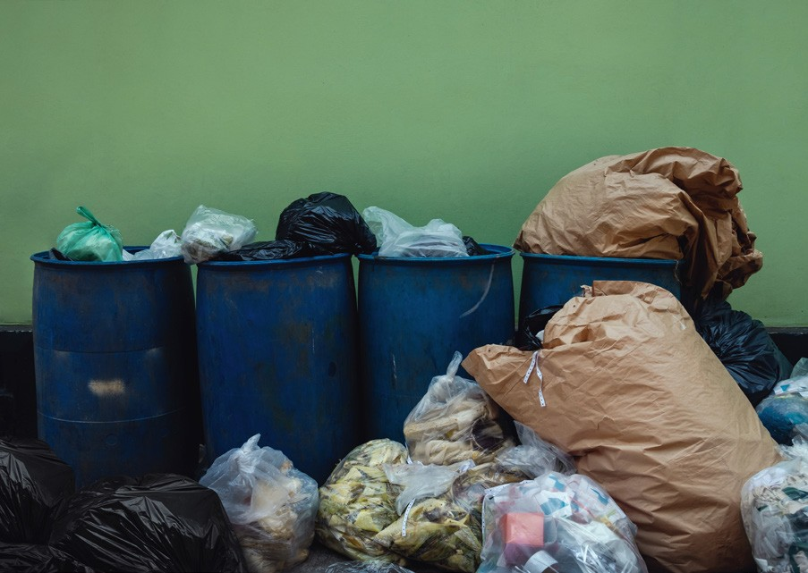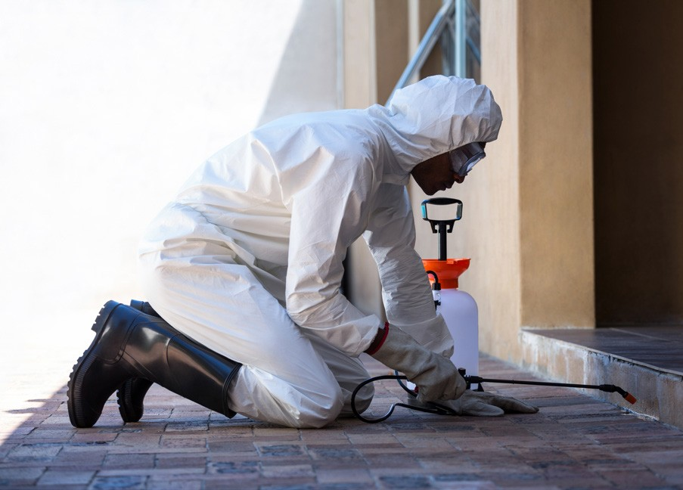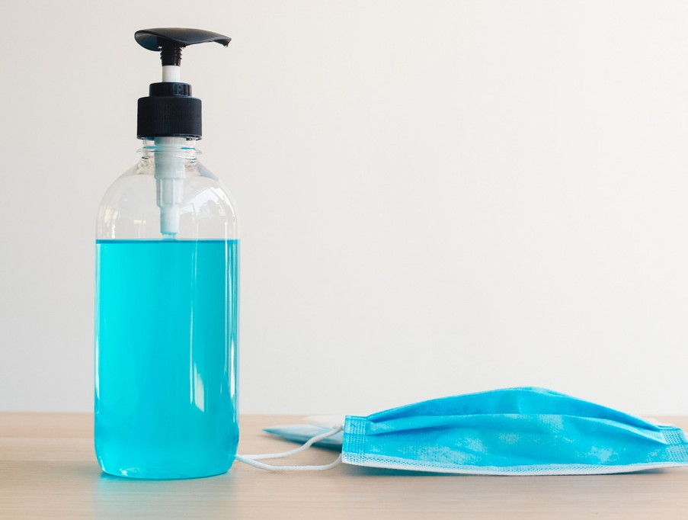

Our Offerings at a Glance
Hygiene Services

Industrial and commercial contract cleaning services
Gardening maintenance

Laundry Services & carpet cleaning
Deep cleaning & Pest control

Waste Management
Supply of facilities consumables

LIST OF PREVIOUS AND CURRENT PROJECTS
Our Company has undertaken various projects since establishment, with our biggest client being Eskom SOC Limited. The list below consists of our current and previous clients:

CLIENT | SERVICES | DURATION
Eskom North West OU | Facilities Management services, Waste Management and Pest Control | 01 June 2016 - date
ESKOM ALICE CNC | Cleaning, Hygiene and Gardening Services | April 2015- to date
ESKOM ALICE SC | Cleaning, Hygiene and Gardening | April 2015- to date
ESKOM MIDRAND | Hygiene supply | May 2016- to date
Zeno Facilities | Cleaning and Gardening Services | May 2013- December  2015
Madikiza Industries | Cleaning, Hygiene and Pest Control Services | January 2013- December

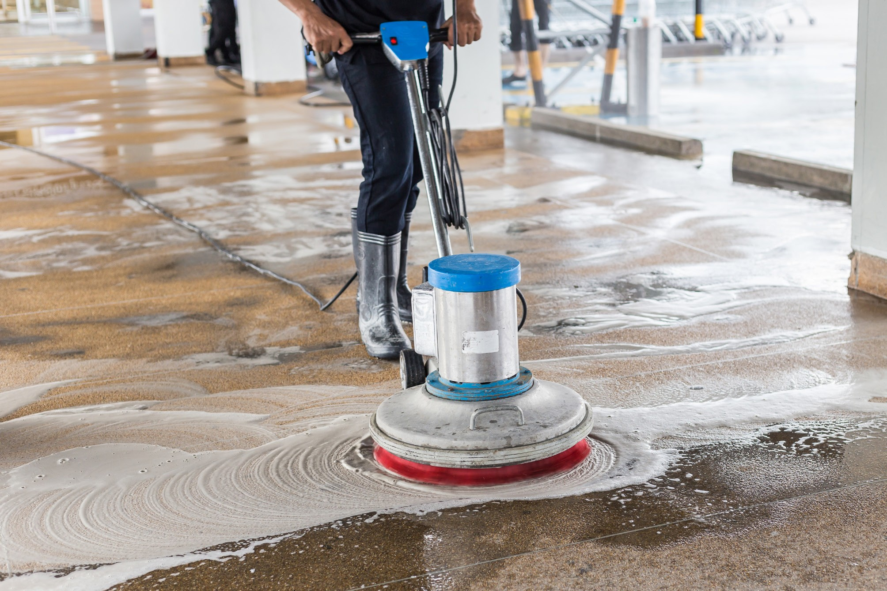

Our Offices

Regus Office Facilities  8 Greenstone Place Stoneridge Office Park Edanvale , 1609  Tel: 081 778 7902  Fax: 086 272 1051 | Rustenburg BRANCH (Satellite Office)  1A Loerie Avenue Safari Gardens Rustenburg 0299  Tel: 014 533 0214  Fax: 086 272 1051 | EAST LONDON (Satellite Office)  Regus Office Facilities Ground Floor, 14 Stewart Dr East London, 5241  Phone: 0860 600 250
Regus Office Facilities First  Floor, Liberty Life Building 21 Aurora Drive  Umhlanga, 4301  Tel: 031 535 7000 | CAPE TOWN (Satellite Office)  Regus Office Facilities Century Way, Century City The Colosseum, First Floor, Cape Town, 7441  Tel: 021 526 0300 | POLOKWANE BANCH  50 Robe Street Ivy Park Ext 2  Tel: 082 226 2057  Fax: 086 272 1051
WITBANK
(Satellite Office)
11184 Mathews Phosa Street
Vosman Witbank 1039
Te;: 076 594 6890
Fax: 086 272 1051

Facilities Management Services
  - Cleaning
  - Hygiene
  - Pest control
  - Waste Management
  - Gardening Services
  - General Supplies

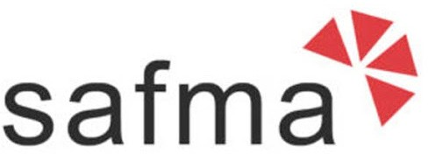
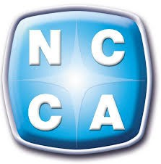
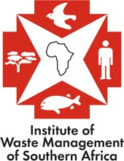
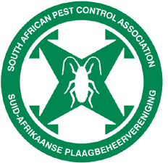
Member of

Contacts
Tel | +27 (0) 81 778 7902
Fax | +27 (0) 86 272 1051
Email | info@nozingagroup.co.za
8 Greenstone Place Stoneridge Offfice Park Edenvale

